PROJECT REPORT

ON

ANALYSIS OF A BANKING AND ONLINE TRANSACTION SYSTEM
A Comparative Study of Software Development Life Cycle Models in Financial Systems

Submitted to

NMAM INSTITUTE OF TECHNOLOGY, NITTE
(Off-Campus Centre, Nitte Deemed to be University, Nitte - 574 110, Karnataka, India)

In partial fulfillment of the requirements for the award of the

Degree of Bachelor of Technology

in

INFORMATION SCIENCE AND ENGINEERING

By

ASHLESH V. NAYAK NNM24IS042

Under the guidance of

Dr. JASON ELROY MARTIS
Associate Professor


2025 – 2026
Comparative Study of SDLC Process Models for a Banking and Online Transaction System
Introduction
In the modern digital era, it had to evolve from traditional branch-based operations into highly complex software-driven online platforms. A Banking and Online Transaction System allows customers to perform various activities; these range from fund transfers and bill payments to account management and applications for loans, to real-time transaction monitoring. Such systems are bound to provide solutions that ensure high availability, security, accuracy, and regulatory compliance, and hence, software development has become not only crucial but highly challenging too.
Such systems depend heavily on the SDLC process model their implementation is based on, as each SDLC model affects how requirements will be gathered, validated, managed, and changed with time. Banking systems operate with sensitive financial data, fall under legal regulations such as RBI guidelines [6], and their user and business requirements are changing quite often. Therefore, choosing an appropriate development model is very important.
The Incremental development model, the Spiral model, and the Waterfall model are described and compared in the report for developing the "Banking and Online Transaction System" [1][2]. A simple Requirements document is included in the report, along with a discussion on the Requirements Engineering Process and the Requirements Validation strategy and the challenges faced in the validation process.

#Scope of the Study

The goal of this study is to look at and compare Software Development Life Cycle models. We will be looking at the Waterfall Model, the Incremental Development Model and the Spiral Model. We want to see how these Software Development Life Cycle models work for a Banking and Online Transaction System. We are focusing on the Software Development Life Cycle models to understand how they are used in a Banking and Online Transaction System.
Banking systems are really big and important. They need to be very secure and reliable. They also need to work and follow all the rules. These systems deal with money information. So they have to follow the rules made by people in charge, like the Reserve Bank of India. Choosing the way to develop these systems is very important for the banking systems to work properly. The banking systems have to be good so they can handle all the money information correctly.
This study is, about:
•To get how each Software Development Life Cycle model works you have to look at how it handles the things the software needs to do and the things that are not necessarily things it needs to do which are called functional and non-functional requirements of the Software Development Life Cycle.
•I want to see how the models deal with problems and unexpected things that happen like when something goes wrong or when we need to make changes to the models. This is what I mean by risk and change management, for the models.
•Analysing their suitability under time and cost constraints
•Examining how requirements engineering practices influence project outcomes [2]
•Studying security and compliance requirements in digital banking systems [6]
The scope includes theoretical analysis supported by established software engineering principles [1][2], industry explanations of SDLC models [3][4][5], and regulatory considerations specific to banking environments [6].
Case Study Overview: Banking and Online Transaction System
The Banking and Online Transaction System is a platform that uses computers to help people with their money. It lets people use the internet and their phones to do things with their money. Nowadays people do not have to go to a bank to do things with their money. They can use the internet and their phones to do it. The Banking and Online Transaction System has to work all the time. It has to make sure that peoples money is safe and that it gets to where it's supposed to go. The Banking and Online Transaction System also has to protect peoples financial information.[1][2]
A digital banking system usually helps people do things like log in to their account check how money they have send money to someone else pay bills see what transactions they have made and get messages right away. Digital banking systems are not like computer programs because they deal with secret information and real money. So if the system has a problem or someone can get into it easily it can cause people to lose money hurt the banks reputation and lead to legal problems, with the digital banking system. The digital banking system has to be very safe and work properly all the time to avoid these issues with the banking system.[3][4]
Online transaction systems have to be really good at working all the time. People who use these systems want to be able to get into their accounts whenever they want. They want their payments to go through right away. So online transaction systems need to be able to handle a lot of people using them at the time without slowing down[5].
Online transaction systems also need to have security. This means online transaction systems need to have encryption and people need to prove who they are, in multiple ways. Online transaction systems need to have ways for different parts of the system to talk to each other and they need to be able to detect when someone is trying to do something bad[6].
Digital banking systems have another part which is following the rules. Banks and other financial institutions have to work within strict rules made by the country about keeping peoples information safe on computers protecting data keeping records of what happens and watching transactions. So the computer system has to have ways to make sure everything can be traced recorded and handled in a way. When people make these systems they have to do it in a way that makes it easy to write down what they did and check everything carefully. Digital banking systems need to be made with care so that they follow all the rules and keep peoples information safe.
When we think about building software for banking and online transactions it is really tough. The people who use these systems want things over time. They want services that are available online. The government keeps changing the rules that these systems have to follow. At the time these systems have to work all the time without stopping. They cannot just stop working. This makes it very important to choose the way to develop software, for banking and online transactions. The Software Development Life Cycle model is a decision because banking and online transaction systems have to be stable and work all the time.
In this case study, the Banking and Online Transaction System is examined as a representative example of a complex and risk-sensitive application. The focus is on understanding how different development models influence requirement management, system reliability, risk handling, and adaptability. By analysing these aspects, the study aims to identify the most suitable development approach for building secure and scalable digital banking platforms.

Key Stakeholders:
- Bank customers
- Bank administrators and staff
- IT and security teams
- Regulatory authorities (e.g., RBI)
- Third-party service providers (payment gateways, SMS/email services)

Core Features:
- User authentication and authorization
- Account management
- Online fund transfers (NEFT, RTGS, IMPS)
- Bill payments and merchant payments
- Transaction history and statements
- Fraud detection and alerts
- Customer support services

Waterfall Model [3]
The sequential stages illustrated in the process diagram are detailed subsequently:
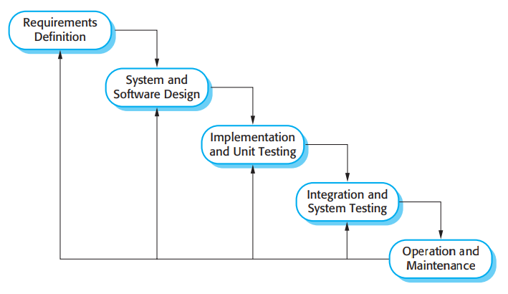
Phase1: Requirements Definition
For Banking and Online Transaction Systems, the requirements definition phase of the development cycle centers on comprehensive identification of system specifications.
This involves gathering operational specifications like account management, money transfer services (NEFT, RTGS, IMPS), utility bill payments, and transaction information.
Non-functionality requirements like security, performance, and availability, and compatibility with RBI's guidelines on digital banking [6], are clearly specified.
These stakeholders will include bankers, bank executives, and technology experts.
This phase generates a Software Requirements Specification document [1], which is the foundation of subsequent development phases.
Phase2: System and Software Design
Architecture and design stage, based on the validated specification, determines the development strategy for the banking platform.
Here, comprehensive system architecture, including computing models like distributed computing systems and configuration of the data repository, is evaluated.
Formulation of security measures, such as data encryption, identity verification, and access control, etc.
User interaction interfaces of digital and mobile banking channels are conceptualized.
This phase ensures that the banking platform is secure, scalable, and reliable before it is actually implemented.
Phase3: Implementation and Unit Testing
In this phase, the actual construction of the banking platform starts.
Specifically, programs for user verification, transactions, and accounts are executed.
Components are tested as separate entities using unit verification to ensure their correct functioning.
Issues related to logical computing, data validation, and business rules are resolved in this phase.
In general, component testing emerges as a critical aspect that can guarantee the success of every banking transaction.

Phase4: Integration and System Testing
After the development of each component, these elements integrate into an overall banking platform.
The components assembled together are examined to check the communication between the modules.
During exhaustive testing, complete banking operations involving user authentications, money transfer, and receipts are being validated.
In order to ensure a safe and efficient transaction, security evaluation and efficiency assessment take place.
This stage verifies that the platform has the desired capabilities and characteristics.
Phase5: Operation and Maintenance
At this final stage, the banking platform is rolled out to the operational environments.
Customers start undertaking transactions using digital banking services.
Whereas maintenance activities include defect remediation, patching, and incremental enhancements.
Continuous surveillance is conducted to monitor the accessibility of the platforms.
Since the waterfall approach has no flexibility in adapting, significant changes in the development process warrant the beginning of the entire process again.

Incremental Development Model [5]
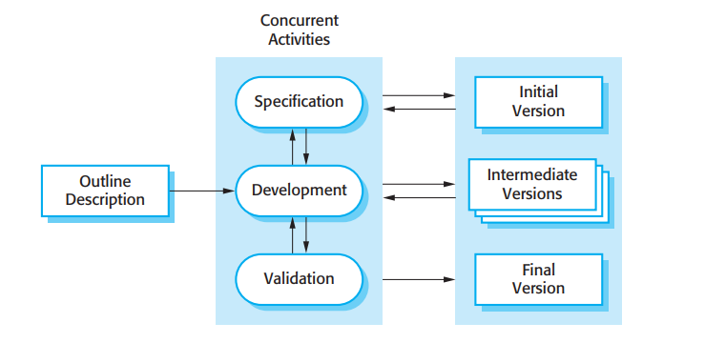
Outline Description
The development process begins with the establishment of a preliminary framework, the framework description of the banking platform.
Top-level specifications, i.e., user authentication, inquiries, and basic monetary transfer, are set.
The specifications are flexible at initial stages.
This framework offers guidance on choosing capabilities in subsequent cycles of enhancements.
This allows for progressive evolution with provision for future modifications.
Concurrent Activities
The methodology diagram illustrates three concurrent activities executed during each enhancement cycle:
1. Specification
Within the activity, specific specifications are set for the current enhancement cycle.
For financial platforms, it may also cover specific features, like handling utility payments or transaction notifications.
Operational and performance specifications are established only for selected capabilities.
Input from earlier iterations is invaluable for improving refinements of specifications.
This methodology allows us to adapt changing requirements.
2. Development
During the implementation phase, capabilities are built for specific banking processes.
More specifically, components that are developed include account services, handling of transactions, and alerts.
Components that previously exist have updates applied to them for improvements such as efficiency and protection.
In each iteration, it grows incrementally from its predecessors.
The implementation remains structured, productive, and concentrated.
3. Validation

The verification process is carried out to confirm the developed enhancements meet established specifications.

Operational validation confirms the correct processing of transactions.

Protection assessments ensure the secure management of confidential financial information.

Customer input steers the refinement of successive improvements.

It quickly finds the issues and minimizes overall development hazards.

Versions of the System

As depicted in the methodology diagram, each enhancement cycle produces an operational platform variant:
Initial Version
Banking services encompassing fundamental operations including access authentication, account review, and transaction examination.
Provided initially to customers for preliminary assessment.
Intermediate Versions
Supplementary capabilities like monetary transfers and utility settlements are also included.
With each version, platform efficiency, user experience, and security measures become better.
Each variant possesses functional and operational stability.
Final Version
Encompasses all planned financial and transaction capabilities.
Thoroughly verified, protected, and conforming to established standards.

Spiral Model [4]
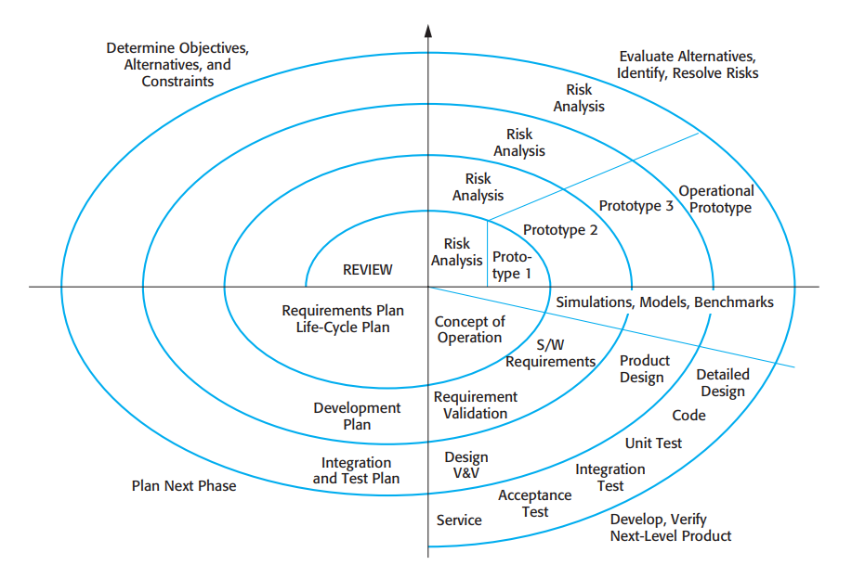
Quadrant 1 - Determine Objectives, Alternatives, and Constraints
Objectives for the present stage are determined at the beginning of every iteration.
Goals may involve banking capabilities such as protected authentication, money transfer, utility settlement, or anomaly detection.
Alternative technical approaches, such as architectural frameworks, protection methodologies, or solutions for data management, get evaluated.
The things that limit what we can do include things like what the RBI says we have to do how we protect things, money issues and when things have to be done. Constraints are things like RBI guidelines they are also about protection characteristics. They are about financial factors and they are, about deadlines.
This section is important for ensuring alignment between development and the organizational demands or regulatory requirements.
Quadrant 2: Develop Alternatives and Identify, Resolve Risks (Risk Analysis)
The core element of the Spiral Model is risk assessment, done in cycles repeatedly.
Protection risks are reviewed along with unauthorized entry to the system, information disclosure, and digital fraud.
Efficiency risks related to high transaction volumes are assessed.
Hazard mitigation approaches include the following:
Testing experimental implementations-versions 1, 2, and 3-of basic banking activities.
Virtual modeling and performance measurement to determine platform capabilities
Construction of functional prototypes for practical validation.
Hence, fewer risks to banking platform security and reliability.
Quadrant 3: Develop and Verify the Next-Level Product
In this quadrant, development and verification activities are carried out.
Software requirements (S/W requirements) are refined.
Product design and detailed design for banking modules are created.
Coding of transaction processing modules, account management modules, and security modules is performed.
Consistent and safe operation is ensured by unit testing, integration testing, and acceptance testing.
Quadrant 4: Plan the Next Phase

After every cycle of conclusion, preparation for the next cycle follows.

The assessment sessions take place with participants, including banking regulatory bodies.

Evolution strategies, schedules for construction, and integration protocols are modified.

The determinations regarding supplementary capabilities, hazards, and improvements have been finalized.

This segment enables regulated progress and improvement.

Key Artifacts Produced in Each Spiral:
As illustrated in the framework diagram, the Spiral Model generates significant outputs including:
- Concept of Operation
- Software and system requirements
- Requirement validation documents
- Product and detailed design
- Tested and integrated code
- Operational system ready for service

Comparative Analysis of SDLC Models for Banking System [3][4][5]

Functional and Non-Functional Requirements:

Criteria | Waterfall | Incremental | Spiral
Functional Requirements | Suitable when requirements are fixed | Supports evolving features | Highly adaptable
Non-Functional Requirements (Security, Performance) | Defined early but hard to revise | Improved gradually | Continuously refined
Compliance Requirements | Well-documented | Moderately documented | Strong focus with risk analysis

Analysis:
Banking platforms require continuous updates to incorporate emerging services as well as regulatory changes. The Progressive Enhancement and Risk-Driven approaches exhibit higher capability in dealing with dynamic changes in operational/performance requirements in regard to rigid Sequential Cascade methodologies that are unable to incorporate any changes[1][2].
Risk and Change Management
Risk Management:
The Waterfall model does not really focus on looking at risks, which's a big problem for banking and online transaction systems. For these systems, security and being accurate with money are extremely important. If you do not look at risks you might not see problems like fraud or data breaches until it is too late. The Waterfall model can be dangerous because it does not let you test and fix things until the end. On the hand the Incremental model is a bit better because it gives you the Waterfall model system in smaller parts. This means you can test each part and get feedback before moving on to the part, which helps reduce risks like transaction failures and security issues with the Waterfall model system. The Incremental model is an improvement over the Waterfall model when it comes to managing risks, for banking and online transaction systems. The Spiral model is really good for managing risks. This is because the Spiral model looks at risks carefully before starting each new part of the project. For this reason the Spiral model is very good for banking systems. The Spiral model is the choice when we talk about managing risks, in banking systems.[4]
Change Handling:
The Waterfall model has a problem. It is really hard to make changes once the development phase starts. This is an issue in banking systems. You see banking systems have a lot of updates and new features all the time.
The Incremental model is a lot better. It lets you make changes between releases. This makes it more flexible and practical for banking platforms.
The Spiral model is even better at handling changes. It actually expects that things will change and it looks at these changes during each cycle of development. The Spiral model and the Incremental model are both better, than the Waterfall model when it comes to banking platforms and banking systems.[1][4]
Time and Cost Constraints
Time Constraints:
The Waterfall model is really slow because people have to wait a time to see the banking system actually work. This is because you only get to see the banking system at the very end.
The Incremental model is better for the banking system because it gives you things like login and fund transfer first. This means people can start using the banking system a lot
The Spiral model is not as fast as the model for the banking system. This is because each time around the model you have to do a lot of extra work like planning and checking for problems and making sure everything is okay, for the banking system.[4]
Cost Constraints:
At first, the Waterfall model appears to be less expensive because of its simple structure. However, if changes are required later, the cost increases significantly. The Incremental model distributes the cost over multiple releases, making financial planning easier for banks. The Spiral model generally has higher costs due to repeated risk analysis, prototyping, and detailed testing, but this cost is justified in banking systems where security and reliability are extremely important.[4]

Requirements Engineering Process
Requirements Engineering is the process that we use to define and document what we need from a system. We have to do this in a systematic way. Requirements Engineering is something that we work on throughout the life of the system. This means we start at the beginning and keep going until the end. We have to make sure the requirements are correct and up to date all the time. This is what Requirements Engineering is, about.[1]
Functional Requirements:
- User Registration and Authentication: The system will let users sign up and log in to their accounts safely. This is done by using a username and password that the system says is okay. This way only the right people can get to the banking services. The system is making sure that people can only get in if they have the credentials, like a username and password to use the banking services.
- Account Balance Inquiry: The system will let users see how money they have in their account at any time. This means they will get current information, about their money. The system is going to give users their account balances in time so they know exactly how much money they have. Users will be able to see their account balances. This will help them with their financial information. The system will provide users with real-time account balances.
- Fund Transfer Services: The system will help people transfer money safely using NEFT, RTGS and IMPS payment modes. This means people can easily send money from one bank to another bank or, within the bank using these NEFT, RTGS and IMPS payment modes.[6]
- Transaction Receipt Generation: The system will make a receipt for every transaction that goes through. This is so we have a record of the transaction and we can look back at it later. The system does this automatically when a transaction is finished successfully. We need these receipts, for record-keeping and so we can reference them if we need to.
- Transaction History and Statements: The system will give you a list of all your transactions and you can even download your account statements. This helps users keep track of what they're spending their money on and manage their money better. The system is really helpful, for people who want to know what is going on with their activities and the system will show them everything they need to know about their financial activities.
- Bill and Merchant Payments: The system will help people pay bills online and do transactions, with merchants. This makes it easy for people to pay for things digitally. The system supports bill payments and merchant transactions which means people can pay for various services online using the system.
- SMS/Email Notifications: The system will send you a message and an email every time something happens with your account. This is so you know what is going on with your money away. The system does this to be clear and open, about what's happening with your account activities. The system wants to make sure you are aware of all transactions.
Non-Functional Requirements:
- Security: The system needs to keep our information safe. It will do this by using encryption from start to finish and making sure people have to prove who they are in ways. This will protect our financial data and stop people who are not allowed from getting to it. The system will make sure our financial information is secure by using these methods to prevent access, to our financial data.[5]
- Performance: The system is supposed to handle transactions fast it should take no more than 2 seconds when everything is working normally. This way the system can be efficient. People who use it can be happy with how it works. The system needs to process transactions within 2 seconds to make sure everything runs smoothly. The users are satisfied, with the system.
- Availability: The system needs to be working all the time so people can use banking services whenever they want. The system should be up. Running for 99.9 percent of the time which means digital banking services are always available. This way people can do their banking online without any problems.[6]
- Scalability: The system we are talking about needs to be able to handle millions of people using it at the time. This means it has to be good, at expanding when the number of users increases. We want the system architecture to support millions of users so that it can keep working smoothly as the number of users grows. The system architecture has to be able to handle this so that the system can keep getting bigger when the user base gets bigger.
- Compliance: The system has to follow the rules made by the Reserve Bank of India for banking and also meet all the standards that are required. This is so that the banking operations are done in an secure way. The system will make sure to do banking operations that're lawful and secure by following the RBI digital banking guidelines and regulatory standards.[6]
- Reliability: The system shall ensure zero data loss during transaction failures through robust backup, logging, and recovery mechanisms.

Requirements Validation Strategy
The banking and online transaction system has to be checked to make sure it does what it is supposed to do. This means checking the requirements of the banking and online transaction system to see if they are correct and complete. The people who are involved in the banking and online transaction system, like the customers and the bank employees have expectations and the system has to meet these expectations.
The banking and online transaction system has to support secure financial transactions. It also has to work the way the business and the government want it to.
The. Online transaction system deals with real money and secret information. So it is very important to check the banking and online transaction system to avoid making mistakes that can cost a lot of money.
The people in charge like banking staff and system analysts look at the requirements that have been written down. They want to make sure these banking staff and system analysts along with cybersecurity experts and the end users who were chosen are all, on the page. Each of the banking staff and system analysts and also the cybersecurity experts and the end users checks the document to make sure it says what they need it to say about how things should work and how things should be kept safe. If something is not clear or is missing the banking staff and system analysts and the cybersecurity experts and the end users work together to fix it at this point.
So we show people some designs for the interface or simple models of the system. These pictures really help people who are interested in the project understand how things like account access and money transfer and payment confirmation will work. When we get feedback from these demonstrations it helps us find things that are missing or things that do not make sense in the system like mistakes, in the way it works.
Preparing test scenarios is another step. We do this directly from the requirements. This way we can confirm that every requirement can be verified through testing. If a requirement cannot be tested in a way this means that the requirement needs to be refined. We need to make sure that every requirement is clear and can be tested. This is where test scenarios come in to help us verify the requirements.
To make sure everything is done and nothing is missed we keep a document called a requirement traceability document. This document links each requirement to the design part that goes with it and the test that checks it so we can see that every requirement is taken care of when we're developing something.[1][2]
#Validation Workflow:
The validation procedure is something that we do in an order. We follow a bunch of steps when we do the validation procedure. The validation procedure has a lot of things that need to be done one, after the other.
First people get together for review sessions. They talk about what's needed for the project. The people involved in the project like stakeholders say what they think is wrong and what should be changed. They also make sure everyone understands what is going on with the requirements.
Next people check if the banking systems are doing what they are supposed to do. The banking systems have to follow a lot of rules, about money and keeping things safe on the computer. So people look at these systems to make sure they are meeting the rules that're in place to keep everything legal and secure. They want to make sure the banking systems are okay when it comes to standards and security standards.
Third we try to make things real by simulating how the system will actually be used. We look at things like what happens when a lot of people are using the system at the time or when the system has to deal with problems. We do this to make sure the banking system requirements really work for real-world banking operations. We want to know if the banking system requirements can handle things, like transactions happening at the same time or if the system can recover when something goes wrong with banking operations.
So when we have made all the changes that people suggested the final version of the requirements document gets officially approved before we start working on the project. The requirements document is really important. It needs to be just right before we begin. The people in charge look, at the requirements document. They give it their formal approval. This means the requirements document is finished and we can start the development of the project. The requirements document is what guides us as we work on the project.

CHALLENGES IN REQUIREMENTS VALIDATION:
Validating requirements in a banking environment presents several difficulties.
One big problem is that security rules are really complicated. These rules usually have a lot of stuff that the business people and the technical people might understand in different ways. The security requirements are very complex. This is a big issue. The business teams and the technical teams look at the security requirements. They do not always see things the same way. The security requirements are hard to understand because they have a lot of details.
People have ideas about what is important. Customers want things to be easy and fast. On the hand the people in charge of making sure everything is done correctly and safely are more concerned about having strong rules and checks in place. The customers want convenience and speed. The compliance and security teams want to make sure they have strict controls and verification measures, for the customers.
The thing about updates is that they happen a lot and this can really mess up the validation process. Sometimes these updates mean that things that were already approved have to be looked all over again to make sure they are still okay. This is the case with updates and the validation process, where regulatory updates can cause problems, for the validation process.
When the system is really busy. A lot of people are using it at the same time predicting how it will behave is a big deal. The system behavior under peak transaction loads is something we have to think about. This is because what actually happens in the world can be different from what we thought would happen when we were planning the system. We have to consider the system behavior, under peak transaction loads to make sure everything works okay.
Lastly, non-functional requirements such as scalability, performance, and reliability are harder to validate because they cannot always be measured precisely during early stages.[2][5]

GitHub Repo Link:

Conclusion:

A system like the "Banking and Online Transaction System" is complex, risky, and dynamic in nature. After comparative analysis, it is obvious that a "Waterfall Model" is not suitable for a complex system, while the "Incremental Model" and "Spiral Model" are suitable for a complex system with a high degree of flexibility and risk management. The importance of requirements engineering and validation mainly influences the security and reliability of the system and its compliance with regulatory requirements. A suitable SDLC model highly influences the success of the system.

References:
- Pressman, R. S. Software Engineering: A Practitioner’s Approach. McGraw-Hill.
- Sommerville, I. Software Engineering. Pearson Education.
- GeeksforGeeks. “Software Development Life Cycle (SDLC).”
- IBM Documentation. “Spiral Model in Software Engineering.”
- TutorialsPoint. “Incremental and Waterfall Models in SDLC.”
- Reserve Bank of India (RBI). “Digital Banking and Payment Security Guidelines.”

DECLARATION OF ACADEMIC INTEGRITY
I hereby declare that this assignment is my original work and has not been copied or plagiarized from any source. All references and resources used have been properly cited. Any ambiguities will lead to forfeiting my marks.

Student Signature: Date:
 13th February 2026

